RUH.AI
V1 System Design & MVP Execution Blueprint
Digital employee operating system built on top of OpenClaw gateway runtimes
Document type | System design document (SDD)
Primary goal | Define the V1 architecture, build scope, and implementation sequence that turns the PRD into an executable platform
Status | Working draft for product, engineering, and design-partner discussions

Why this document exists
The PRD defined the platform ambition. This document narrows the build to the minimum system that can reliably create digital employees, let them collaborate through governed workflows, and run them in trust-bounded OpenClaw runtimes.

Executive snapshot
Decision area | V1 choice
Architecture shape | Shared Ruh.ai control plane + dedicated runtime plane per customer trust boundary
Primary runtime | OpenClaw gateway handles agents, workspaces, sessions, routing, tools, skills, hooks, and cron [R1]-[R6]
Primary Ruh.ai value | Template registry, deployment compiler, task graph orchestration, approvals, secrets brokerage, evals, and analytics
Default collaboration model | Typed tasks + artifacts + approval states. Direct agent-to-agent chat is not the default enterprise path [R7]
V1 build target | Create employees from templates, assign work across employees, gate risky actions, and push auditable results into systems of record

1. Purpose of this document
This system design document converts the platform PRD into an implementation blueprint for Ruh.ai V1. It defines the system boundary, runtime model, core services, collaboration contract between digital employees, security posture, and phased delivery plan.
The target reader is the founding team, engineering leads, product leads, and design-partner stakeholders who need one shared answer to a simple question: what exactly are we building first, and how will it work in production?
Decisions this document locks
1) one OpenClaw gateway per customer trust boundary; 2) one control plane for authoring, deployment, policy, and analytics; 3) typed task graph as the default collaboration layer; 4) curated skills/plugins only in production; 5) approvals on all medium/high-risk actions; 6) V1 success measured by task completion, approval quality, cycle-time reduction, and cost per completed workflow.

1.1 What this document is not
- It is not a customer proposal or go-to-market deck.
- It is not a low-level API specification with endpoint payloads.
- It is not a promise to build every platform ambition in the PRD during V1.

1.2 V1 product statement
Ruh.ai V1 is a multi-tenant control plane that lets an operator compose, deploy, supervise, and improve cooperating digital employees inside isolated OpenClaw runtimes. The system should make it possible to deploy the same employee architecture to different customers by changing templates, packs, connectors, and policies rather than rebuilding agent logic from scratch.

2. Design constraints inherited from OpenClaw
OpenClaw is the runtime operating layer, not the whole product. Its official docs describe support for isolated agents with workspaces, auth, and routing [R1], configuration of channels, tools, sandboxing, hooks, and cron [R6][R9], filesystem-based skills [R4], event-driven hooks [R2], built-in cron [R3], session-spawn tools for agent-to-agent interactions [R7], and optional Docker-based sandboxing [R6].
The most important constraint is security posture. OpenClaw explicitly documents a personal-assistant trust model: one trusted operator boundary per gateway. It does not claim hostile multi-tenant isolation on one shared gateway and recommends separate gateways or separate OS users/hosts for mixed-trust scenarios [R5].
Constraint | What it means for Ruh.ai
Gateway trust model | Never place unrelated customers or adversarial business units on one shared OpenClaw gateway [R5].
Workspace model | Treat workspace as memory and default cwd, not as a hard sandbox; isolation requires sandboxing [R8][R6].
Plugin/skill surface | Only reviewed, pinned, curated packages are allowed in production because third-party skills/plugins must be treated as untrusted code [R4].
Agent-to-agent tools | Available in OpenClaw, but enterprise collaboration should default to Ruh.ai task graph records for better auditability [R7].
Sandboxing | Optional, helpful, but not a perfect boundary. Ruh.ai still needs policy, trust partitioning, and separate credentials [R6].

3. V1 scope and release boundary
The biggest failure mode at this stage is building too much control-plane complexity before proving the core loop. V1 should therefore focus on the smallest system that can do four things well: create an employee from a template, route work between employees, gate risky actions, and produce measurable results in a system of record.
In V1 | Out of V1
Employee templates and instance creation | Public marketplace for third-party packs
Pack registry with curated, versioned assets | Self-serve public plugin installation into production
Deployment compiler to OpenClaw config/workspaces | Unrestricted human-free autonomous execution
Task graph orchestration and artifact states | Cross-tenant shared runtime clusters
Approvals, audit logs, and replay | Per-action fine-grained billing and revenue sharing
Connector set: Slack, email, Jira/Linear, GitHub, Drive/Docs/Notion | Full ERP/finance automation on day one
Basic evals, cost telemetry, and operational dashboards | Advanced ML personalization and autonomous optimization loops

3.1 V1 success metrics
Metric | Definition | V1 target direction
Employee creation time | Time from template selection to active runtime deployment | Less than 30 minutes for a standard pack
Task completion rate | Share of assigned tasks completed without manual rework | Increase steadily per pack and per customer
Approval acceptance rate | Share of medium/high-risk actions approved without rewrite | Above 70% for mature workflows
Time-to-artifact | Elapsed time from inbound signal to usable artifact or system update | Meaningfully faster than manual baseline
Run failure rate | Share of runs failing due to runtime, policy, or connector errors | Low and falling with each release
Cost per completed workflow | Model + runtime cost divided by successful workflow completions | Track and cap by pack/customer

4. Reference architecture
The product uses a strict two-plane architecture. The control plane is multi-tenant and owns authoring, deployment, policy, and analytics. The runtime plane is customer-scoped and executes work in one or more isolated OpenClaw gateways. This is the only architecture that respects OpenClaw’s documented trust boundary while still giving Ruh.ai the leverage of a shared product core [R5].
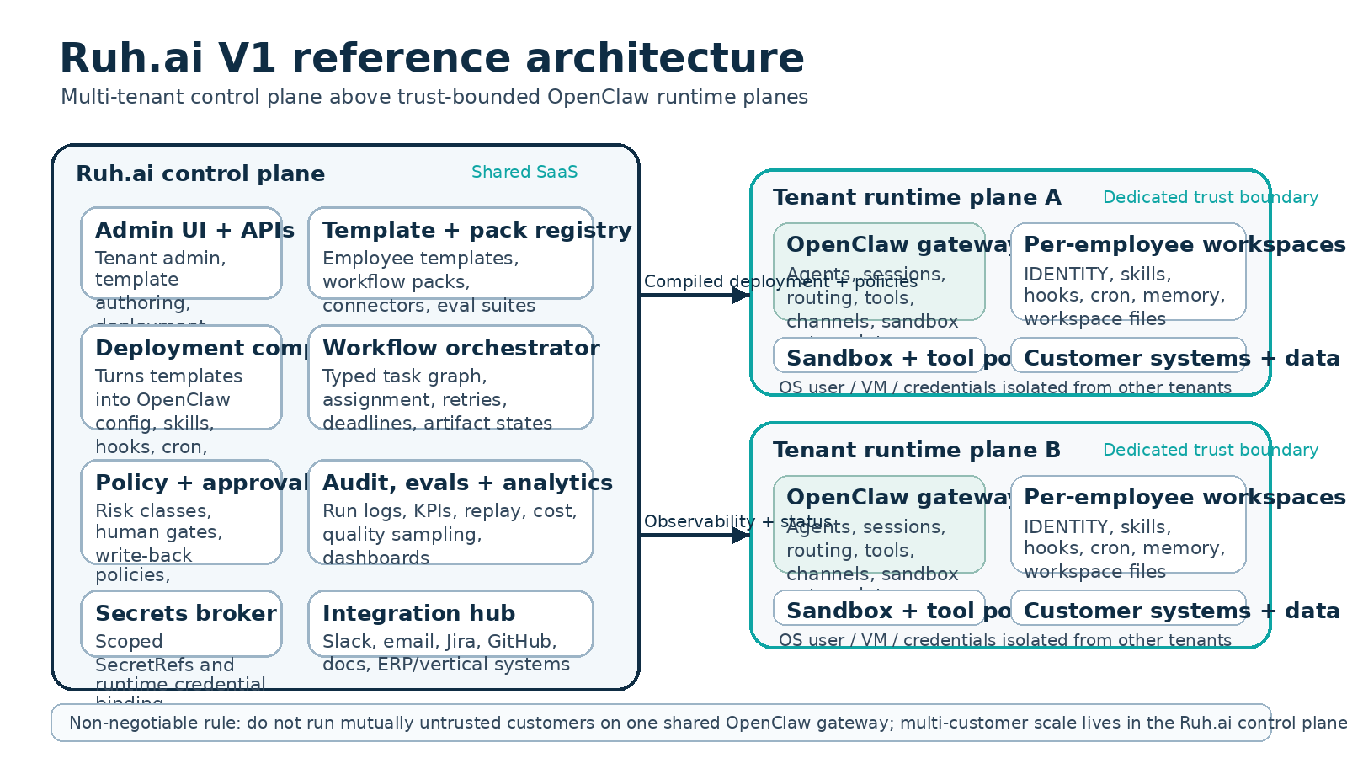
Figure 1. Shared Ruh.ai control plane above trust-bounded OpenClaw runtime planes.

4.1 Component responsibility split
Capability | OpenClaw runtime plane | Ruh.ai control plane
Agent execution | Agents, sessions, routing, channel bindings, tools, sandbox entrypoint [R1][R6] | Defines what to deploy and under which policy
Behavior packaging | Loads workspaces, skills, hooks, cron [R2][R3][R4] | Compiles templates and packs into deployable runtime assets
Workflow coordination | Basic agent-to-agent/session tools exist [R7] | Owns task graph, artifacts, dependencies, retries, deadlines, approvals
Tenant governance | Not a hostile multi-tenant boundary [R5] | Owns tenant model, roles, policy, audit, secrets references, usage accounting
Quality management | Runtime logs and raw transcripts | Owns eval suites, run scoring, quality sampling, dashboards, and replay UI

4.2 Non-negotiable architecture rules
- Every deployment belongs to one tenant trust boundary and maps to one dedicated runtime environment.
- A runtime environment may contain several employees for the same tenant, but never employees from unrelated customers.
- Employees collaborate through Ruh.ai tasks and artifacts by default. Direct session-to-session messaging is limited to controlled internal patterns.
- Secrets are referenced by policy and injected at runtime; they are not hard-coded into workspaces or pack assets.
- Any external send, irreversible write-back, elevated tool call, or policy exception requires approval unless explicitly marked low-risk by policy.

5. Core service design
Ruh.ai V1 should be built as a small set of explicit backend services rather than one monolithic API. Each service exists because it maps to a different responsibility boundary and will evolve at a different pace.
Service | Primary job | State owned | V1
Identity & tenant service | Organizations, users, roles, trust boundaries, environments | Tenant, user, role, deployment environment | Required
Template & pack registry | Versioned employee templates, pack assets, workflow templates, connector presets | Template metadata, pack versions, compatibility matrix | Required
Deployment compiler | Compiles templates/packs into runtime bundles for OpenClaw | Rendered config, workspace tree, package manifest | Required
Runtime manager | Applies deployments, tracks gateway health, package drift, and status | Deployment state, runtime inventory, heartbeat | Required
Workflow orchestrator | Creates and advances task graphs, assigns employees, handles retries and escalations | Work items, tasks, state transitions | Required
Artifact service | Stores structured outputs and references used across runs and employees | Artifacts, lineage, system receipts | Required
Policy & approval service | Risk classification, human gates, override logs, write-back permissions | Approval requests, policy versions, decision logs | Required
Connector hub | Normalizes inbound/outbound events across systems | Connector configs, webhook receipts, mapping state | Required
Secrets broker | Scoped credential bindings and short-lived secret resolution | Secret refs, lease logs, access grants | Required
Observability & eval service | Run logs, traces, cost, quality samples, eval outcomes | Run telemetry, scores, dashboards | Required
Search/context service | Document retrieval, task-context assembly, memory references | Indexes, embeddings, source map | Phase 2

5.1 Deployment compiler
The deployment compiler is the heart of the product. It is the subsystem that converts a reusable, customer-neutral employee definition into a customer-specific OpenClaw runtime package.
- Input: employee template, selected pack(s), tenant policy profile, connector bindings, model profile, channel bindings, secret references, and environment metadata.
- Output: gateway config diff, employee workspace tree, skill folders, hook folders, cron definitions, identity files, connector mapping manifest, and deployment checksum.
- Behavior: deterministic build, versioned manifest, dry-run preview, environment validation, compatibility checks, and rollback package creation.

deployment/
manifest.json
gateway-config.json5
employees/
intake-coordinator/
IDENTITY.md
skills/
hooks/
memory/
policies/
reviewer/
IDENTITY.md
skills/
hooks/
cron/
connector-mappings/
secret-bindings.json

5.2 Workflow orchestrator
The orchestrator owns business collaboration. It should not depend on transcripts to represent business state. Instead it should model each workflow as a graph of typed tasks with explicit inputs, outputs, deadlines, and approval rules.
Function | Design choice
Work item intake | Every inbound signal becomes a normalized work item with source references and idempotency key.
Planning | Workflow template expands into a task graph; planner can add or remove optional tasks based on context.
Assignment | Tasks are assigned to one employee instance according to role compatibility, load, and policy.
Execution | The assigned employee receives a run package containing task payload, artifact refs, context slice, and allowed tools.
Completion | Employee must emit structured result, artifact refs, recommended next state, and confidence or issue flags.
Escalation | Policy failure, deadline breach, connector error, or low confidence opens escalation and may reassign to another employee or human.

5.3 Secrets broker
The runtime must never rely on long-lived plain-text credentials embedded in packs or workspaces. Instead the control plane stores secret references and issues scoped bindings per employee, per connector, and per environment.
- One logical secret may have several environment-specific bindings (sandbox, staging, production).
- Employees request capabilities, not raw secrets, whenever possible.
- Secret access is logged and linked to task run IDs.
- Rotation invalidates future leases without requiring pack rewrites.

6. Core data model
The data model must stay stable even if individual models, connectors, or vertical packs change. The platform should therefore be anchored around business objects rather than agent-specific runtime artifacts.
Entity | Purpose | Key fields
Tenant | Top-level customer organization | tenant_id, name, plan, trust_boundary_policy
RuntimeEnvironment | Dedicated execution boundary for one tenant or business unit | environment_id, tenant_id, gateway_target, region, status
Workspace | Business-scoped working context within a tenant | workspace_id, tenant_id, name, pack_set, data_sources
EmployeeTemplate | Reusable role definition independent of one customer | template_id, role_name, capabilities, tool_profile, output_contracts
EmployeeInstance | Deployed employee bound to one runtime/workspace | employee_id, template_id, workspace_id, runtime_binding, status
PackVersion | Versioned bundle of templates, workflows, connectors, evals | pack_id, version, compatibility, changelog
Entity | Purpose | Key fields
WorkflowTemplate | Reusable graph definition for a repeatable process | workflow_id, task_defs, transitions, default_approvals
WorkItem | Normalized inbound request or trigger | work_item_id, source, type, priority, source_refs, status
Task | Atomic unit of work assigned to one employee | task_id, work_item_id, assignee, input_schema, due_at, state
Artifact | Structured output or referenced document produced during work | artifact_id, type, uri, schema_version, lineage
ApprovalRequest | Human or policy gate over a planned action | approval_id, action_type, risk_class, approver, decision
Run | One execution attempt by one employee for one task | run_id, task_id, employee_id, model_profile, cost, outcome
EvalCase | Quality test linked to a template, pack, or workflow | eval_id, subject_type, subject_id, dataset_ref, threshold

6.1 Canonical relationships
- A tenant owns one or more runtime environments, but a runtime environment belongs to exactly one trust boundary.
- A workspace belongs to one tenant and can host several employee instances drawn from several templates.
- A pack version can contribute templates, workflows, connectors, and evals, but its assets are immutable once released.
- A work item expands into one or more tasks; each task can produce zero or more artifacts and zero or more approval requests.
- A run is always linked to exactly one task and one employee instance, so every tool action and model cost can be traced back to a business step.

7. Collaboration model for digital employees
The defining product behavior is not that one employee can chat. It is that many employees can cooperate without losing state, safety, or accountability. Ruh.ai therefore uses a typed collaboration model with three layers: task graph, artifact layer, and runtime execution.
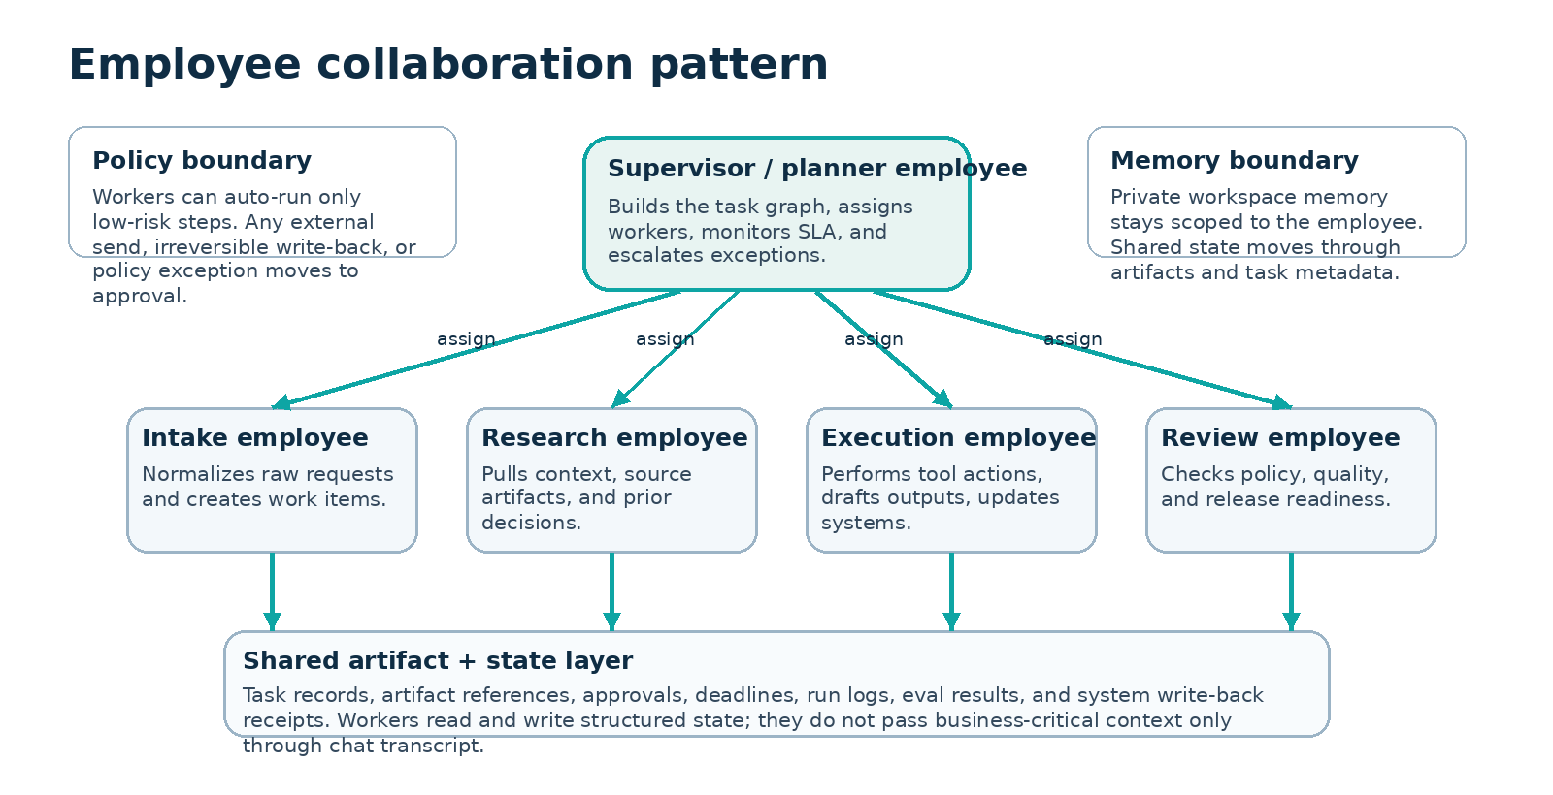
Figure 2. Recommended collaboration pattern: supervisor assigns workers through typed tasks and shared artifacts.
Layer | Purpose | Rule
Task graph | Owns assignment, dependencies, deadlines, and status | Every business action starts from a task or subtask record.
Artifact layer | Owns shared business memory | Employees exchange business context through artifacts and structured metadata, not only through chat.
Runtime execution | Owns the actual agent turn inside OpenClaw | The run package is derived from the task graph and policy engine, then executed in the employee workspace.

7.1 Collaboration rules
- Each task has one primary assignee. Multi-owner ambiguity is not allowed.
- Shared business context is written to artifacts or task fields. Private reasoning and scratch work stay inside the employee workspace/session.
- Any employee may request a subtask, but only the orchestrator creates the official task record and assigns it.
- Employees can propose state transitions; the orchestrator commits the state transition after validating contracts and approvals.
- Two employees must never write back to the same external record concurrently without a lock or optimistic concurrency check.

7.2 Default employee patterns in V1
Pattern | When to use | V1 support
Supervisor + workers | One planner routes to several specialists | Required
Single employee workflow | A narrow job can be completed by one employee | Required
Human checkpoint chain | Several employees prepare work, human signs off material step | Required
Free-form swarm | Open-ended many-agent exploration without typed tasks | Not supported by default

8. Task lifecycle and execution flow
The platform needs one universal lifecycle that can support construction operations, software delivery, support, or internal operations. The same lifecycle should apply regardless of vertical pack.
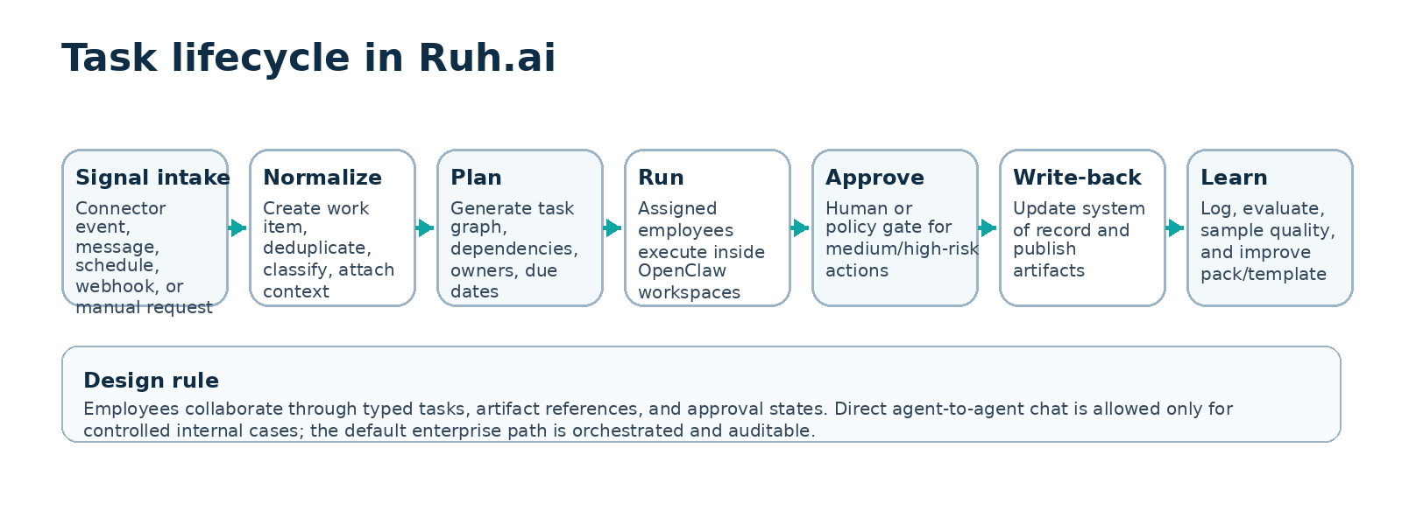
Figure 3. Universal task lifecycle used by Ruh.ai workflows.

8.1 Task states
- Received - signal captured but not yet normalized.
- Ready - work item normalized and eligible for planning.
- Planned - task graph created and waiting for assignment.
- Running - one or more tasks actively executing.
- Blocked - waiting on approval, connector recovery, or missing information.
- Completed - accepted result written to artifact layer and next state committed.
- Failed - unrecoverable error or policy stop; human action required.
- Canceled - intentionally stopped by operator or superseded by a newer task.

8.2 Execution sequence
Step | Owner | Result
1. Intake | Connector hub | Inbound event normalized into work item with idempotency key and source refs.
2. Plan | Workflow orchestrator | Task graph created from workflow template and context.
3. Context build | Search/context service | Run package assembled: instructions, artifacts, source docs, tool policy, budget.
4. Execute | Runtime manager + OpenClaw | Employee run starts in the correct workspace and session.
5. Validate | Policy/eval service | Result contract, safety checks, and risk classification applied.
6. Approve if needed | Approver or auto-policy | Action allowed, rejected, or sent back for revision.
7. Write-back | Connector hub | System of record updated; receipt linked to task and artifact.
8. Observe | Observability service | Logs, cost, timing, and quality score recorded for analytics and replay.

8.3 Failure handling
Failure class | Example | System behavior
Connector failure | Jira/GitHub/Slack unavailable | Retry with backoff, keep task blocked, notify operator after threshold.
Policy failure | Employee attempts disallowed tool or risky action | Stop action, log policy event, create escalation task.
Contract failure | Result missing required fields or artifact refs | Request revision from same employee or reassign to reviewer.
Runtime failure | Gateway offline, workspace unavailable, model timeout | Mark run failed, preserve task state, allow replay after recovery.
Quality failure | Eval or human review rejects output | Return task to planned/running with feedback attached.

9. Security, trust boundary, and policy design
Security is a product feature, not a later hardening pass. This matters even more because OpenClaw itself documents that one gateway represents one trusted operator boundary and that sandboxing is only a partial blast-radius reduction, not a complete hostile-tenant boundary [R5][R6].
Security baseline for production deployments
One runtime environment per tenant trust boundary; dedicated OS user or VM/container per runtime; sandboxing enabled for production task execution; workspace access limited by need; curated skills/plugins only; outbound connectors registered explicitly; approval gates on all medium/high-risk actions; gateway health and security audit checked continuously [R5][R6].

9.1 Risk classes
Class | Examples | Default policy
Low | Read-only retrieval, draft generation, internal summarization, artifact tagging | Auto-execute and log
Medium | Editing an external ticket, sending internal message, updating shared docs, scheduling a follow-up | Require policy check; human approval configurable by tenant
High | External customer send, irreversible write-back, payment/contract action, elevated host execution, production code merge or deploy | Human approval required; dual control optional

9.2 Platform roles
Role | Permissions
Platform admin | Manage global templates, packs, deployment defaults, and control-plane operations.
Tenant admin | Manage users, workspaces, connectors, approvals, runtime environments for one tenant.
Pack author | Create/update templates, workflows, evals, and connector presets subject to review.
Operator | Trigger deployments, approve actions, inspect runs, replay failures.
Auditor | Read-only access to logs, artifacts, approvals, and telemetry.

9.3 Required controls
- Deployment signing and immutable manifests so runtime drift can be detected.
- Per-connector allowlists and per-employee tool profiles.
- Runtime heartbeat with gateway version, package checksum, sandbox mode, and connector health.
- Replay mode that can inspect past runs without reusing live credentials.
- Retention controls for transcripts, artifacts, and audit logs by tenant policy.

10. Integration model
Integrations are how the platform becomes useful. But integrations should enter V1 through a single connector contract so every new system does not require a different orchestration model.
Connector family | V1 direction | Use in workflows
Messaging | Slack first, email second | Inbound requests, approvals, internal delivery, exception alerts
Work tracking | Jira or Linear | Create/update issues, sync state, attach artifacts
Code/repo | GitHub | Link PRs, code changes, issues, releases, and status checks
Knowledge/docs | Google Drive/Docs or Notion | Read policies, SOPs, specs, write summaries or status docs
Future vertical systems | Construction platforms, ERP, helpdesk, CRM | Add through pack-specific connector presets after core platform proves out

10.1 Connector contract
- Every connector must support receive(), send()/write_back(), map_identity(), and health_check().
- Every inbound event must be normalized into a common envelope: source, actor, object_id, event_type, body, attachments, timestamps.
- Every write-back must return a receipt with external ID, status, timestamp, and conflict/version data where available.
- All connector calls must be idempotent or wrapped with Ruh.ai idempotency keys.

11. Observability, evals, and operations
Without observability the product will feel magical during demos and unreliable in production. Ruh.ai must therefore treat every run as an inspectable operational object with cost, timing, tool events, approvals, and quality outcomes attached.
Dimension | Minimum V1 telemetry
Run telemetry | start/end time, assignee, task_id, model profile, tokens, cost, outcome
Tool telemetry | connector name, tool/action, latency, success/fail, retry count
Workflow telemetry | time in state, blocked duration, approval latency, completion rate
Quality telemetry | human score, eval score, approval acceptance, rework reason
Runtime telemetry | gateway status, package checksum, sandbox mode, queue depth, connector health

11.1 Eval model
V1 evals do not need to be academically sophisticated. They do need to be good enough to catch obvious breakage before and after deployment.
- Template smoke tests: can the employee start, read required context, and emit the expected contract?
- Workflow regression tests: given a representative input, does the workflow end in the correct artifact and state?
- Write-back safety tests: does the policy layer correctly block unsafe actions and require approvals?
- Quality sampling: operators review a sample of completed tasks and score usefulness, correctness, and trustworthiness.

11.2 Operational runbooks required before pilot launch
Runbook | Purpose
Deployment rollback | Revert a bad pack/template or runtime package quickly
Connector outage handling | Pause work and preserve state when third-party systems fail
Gateway recovery | Restart or replace a tenant runtime without losing task graph state
Secret rotation | Rotate connector credentials safely and rebind active employees
Approval backlog handling | Prevent blocked high-risk tasks from silently aging out

12. MVP release plan
The release plan is intentionally sequenced so that the platform proves the core loop before deeper optimization or broader integrations.
Phase | Goal | Outputs
0. Foundations | Establish deployable trust-bounded runtime | Tenant model, runtime environment, gateway health, basic auth, deployment manifest
1. Employee creation | Turn templates into active employees | Template registry, pack registry, deployment compiler, runtime manager, employee list/status
2. Collaboration core | Allow employees to work together through governed tasks | Workflow orchestrator, artifact service, task UI/API, retries, escalation, approvals
3. Operational value | Connect to real systems and measure value | Slack/email + Jira/Linear + GitHub/Docs connectors, dashboards, replay, cost and quality telemetry
4. Pack hardening | Prepare for design-partner reuse and industry expansion | Versioning discipline, pack compatibility matrix, eval suites, migration tooling

12.1 Recommended first pilot workflows
Workflow | Why it fits V1 | Suggested employees
Issue intake to triage | High volume, low external risk, easy ROI | Intake employee, reviewer employee
Spec to implementation planning | Useful in AI/software teams and reusable across other domains | Planner employee, research employee
Status collection and weekly summary | Common across construction, software, and operations | Coordinator employee, reviewer employee
Support request to routed action | Strong audit needs and connector value | Support employee, execution employee, approver

13. Key risks and open questions
Risk or question | Why it matters | Current answer
Overuse of raw agent-to-agent chat | Loses auditability and makes workflows hard to debug | Default to typed tasks; limit direct session tools to controlled patterns
Shared gateway temptation | Would violate trust boundary and create cross-tenant risk | Explicitly disallow in production architecture
Pack sprawl | Could recreate bespoke consulting inside the product | Use strict pack versioning and approval for new reusable assets
Context overload | Too much retrieval context will raise cost and reduce quality | Use task-specific context assembly and budgets
Who owns policy changes? | Unsafe policy edits could silently widen authority | Version policies and require admin review with audit trail

14. Definition of done for V1
- A tenant admin can deploy at least two cooperating employees from a versioned pack into a dedicated runtime environment.
- Those employees can complete one production workflow through the full lifecycle: intake, planning, execution, approval, write-back, and analytics.
- All medium/high-risk actions are gated by the policy and approval service with full audit history.
- The platform can replay a failed run, inspect the artifact lineage, and show runtime/package/version information for debugging.
- At least one design partner can adopt the same core platform with a different pack or workflow configuration rather than a new underlying architecture.

Appendix A. Example employee template contract
Field | Example
role_name | Intake Coordinator
goal | Turn messy inbound requests into normalized work items with source references and priority.
allowed_inputs | Slack message, email thread, webhook event, manual form entry
required_outputs | work_item payload, source refs, priority, proposed workflow route
tool_profile | read connectors, issue create/update, docs read, no elevated exec
risk_profile | Low by default; medium if updating shared issue state
kpis | time-to-work-item, classification accuracy, rework rate

Appendix B. Example task payload passed into runtime
{
"task_id": "task_01293",
"workflow_id": "wf_issue_triage_v1",
"employee_id": "emp_intake_coordinator_a",
"objective": "Normalize inbound bug report and route it",
"input": {
"source": "slack",
"message_id": "sl_88192",
"body": "Customer reports eval failures after model update"
},
"artifacts": [],
"allowed_tools": ["slack.read", "jira.create", "docs.search"],
"policy": {
"risk_class": "low",
"requires_approval": false
},
"budget": {
"max_turns": 6,
"max_cost_usd": 0.50
}
}

References
[R1] Agents - OpenClaw (isolated agents: workspaces, auth, and routing) - https://docs.openclaw.ai/cli/agents
[R2] Hooks - OpenClaw (event-driven automation inside the gateway) - https://docs.openclaw.ai/automation/hooks
[R3] Cron Jobs - OpenClaw (built-in persistent gateway scheduler) - https://docs.openclaw.ai/automation/cron-jobs
[R4] Skills - OpenClaw (filesystem-based SKILL.md packages and security notes) - https://docs.openclaw.ai/tools/skills
[R5] Security - OpenClaw (one trusted operator boundary per gateway; not a hostile multi-tenant bus) - https://docs.openclaw.ai/gateway/security
[R6] Sandboxing - OpenClaw (optional Docker-based sandboxing and workspace access modes) - https://docs.openclaw.ai/gateway/sandboxing
[R7] Tools - OpenClaw (agent-to-agent sessions_spawn / sessions_send and session visibility) - https://docs.openclaw.ai/tools
[R8] Agent Workspace - OpenClaw (workspace as memory/default cwd, not a hard sandbox) - https://docs.openclaw.ai/concepts/agent-workspace
[R9] Configuration - OpenClaw (channels, tools, sandboxing, hooks, cron) - https://docs.openclaw.ai/gateway/configuration

